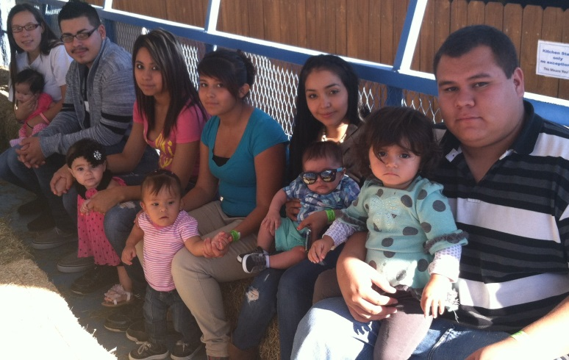
Hatch Valley High School GRADS
In the fall of 2007, Hatch Valley High School opened its GRADS program. The GRADS program has become an important aspect of the High School. GRADS students at Hatch Valley High School are given the support and encouragement they need to complete the requirements to receive their high school diploma. The program has a day care component that allows the students to concentrate on their classes while knowing their child is in a safe and nurturing environment.
The Little Bear Child Development Center and Daycare is located on the campus at Hatch Valley High School. It is a licensed child care center where the children are safe and secure while their parents pursue their education in order to break the cycle of poverty. Center staff focuses upon modeling appropriate parenting skills and promoting healthy parent-child relationships to help break the cycle of learned child abuse and neglect. They offer early detection of infant developmental problems and provide assistance in making the appropriate diagnostic and intervention referrals.
HVHS GRADS participates in several community and educational events each year. In 2013, we traveled to Santa Fe for GRADS day at the legislature and where participants were given the opportunity to meet with local representatives and discuss how GRADS has allowed them to continue with their high school education. We are excited to participate in this program again this year! Ous students also attended training on FAS to become peer educators. Hatch GRADS was able to go on positive parenting outings to Dona Ana Community College, El Paso Zoo, and Ten Pin Alley. GRADS also hosted a Teen Career Expo where they were given information on different careers and services available to them after graduation.
Many of the students who are enrolled in GRADS and access the child care services would be unable to complete High School without the support they receive by being part of the GRADS program. GRADS is a very valuable program at Hatch Valley High School.

